How to Join a Zoom Meeting:
Via Computer:
- You will receive an invite by the host of the Zoom meeting via email. On the actual email you can click on the link, which is specific for every call
Join Zoom Meeting: https://zoom.us/j/632560221
- Once the link is clicked, a pop up will appear entitled “Open URL: Zoom Launcher” which will read https://zoom.us wants to open this application.
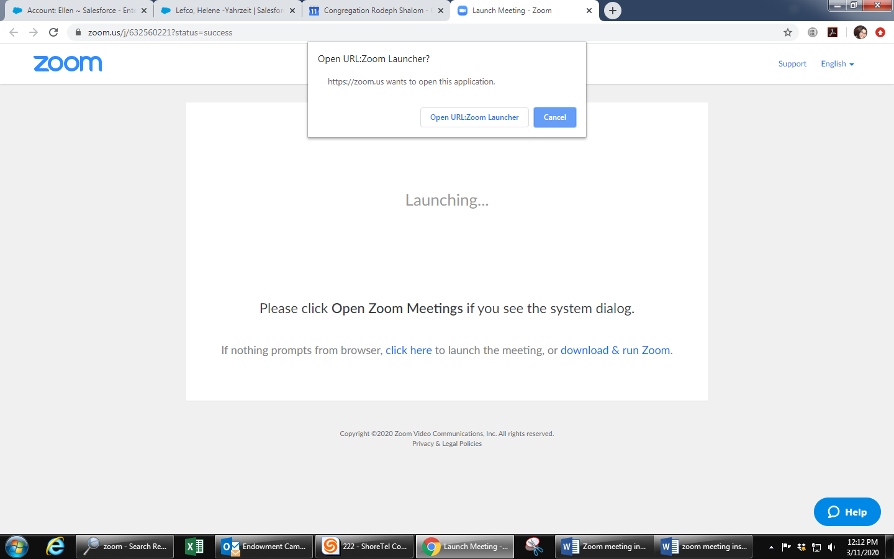
- Click “Open URL Zoom Launcher”
- A pop-up screen will appear
- If your computer does not have a microphone, dial in by using the phone number (New York) that was assigned in the email invitation you received
- If you are using your computer camera, when the host appears on the screen, you are all set!

Via Zoom App for iPhone
- Open the Zoom mobile app. If you have not downloaded the Zoom mobile app yet, you can download it from the App Store.
- Join a meeting using one of these methods:
  - Tap Join a Meeting if you want to join without signing in.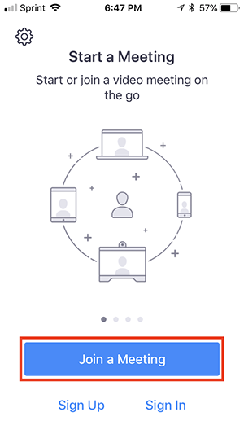
  - Sign in to Zoom then tap Join.
- Enter the meeting ID number and your display name.
  - If you're signed in, change your name if you don't want your default name to appear.
  - If you're not signed in, enter a display name.
- Select if you would like to connect audio and/or video and select Join.
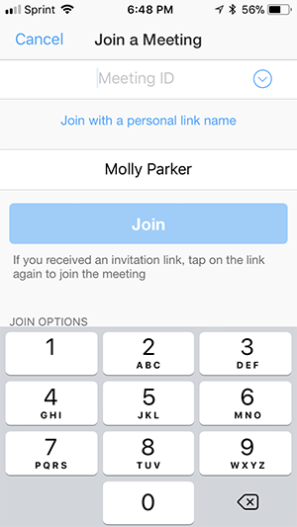
- Open the Zoom mobile app. If you have not downloaded the Zoom mobile app yet, you can download it from the App Store.
- Join a meeting using one of these methods:
  - Tap Join a Meeting if you want to join without signing in.
  - Sign in to Zoom then tap Join.
- Enter the meeting ID number and your display name.
  - If you're signed in, change your name if you don't want your default name to appear.
  - If you're not signed in, enter a display name.
- Select if you would like to connect audio and/or video and select Join.
Via Phone Call:
1. On your phone, dial the teleconferencing number provided in your invite.
2. Enter the meeting ID number when prompted using your dialpad.
Note: If you have already joined the meeting via computer, you will have the option to enter your 2-digit participant ID to be associated with your computer. If you have not joined on your computer, simply press # again when prompted to enter in your participant ID.

